**File: V****alentin_Varbanov_4_041472.rb**

Task:

|  |
| --- |
| Develop a program named FirstName_LastName_ClassNumber_041472.rb |
|  |
| 1. you are given two arguments for a folders with files; |
| 1.1 if there are other arguments they should be discarded; |
| 2. file names in this folders are in the form First_Last_digits.rb; |
| 3. find the students that are only in the first folder and not in the second. A student is in both folders if it there is a file with the same First and Last Name. Digits might be different; |
| 4. Sort the result by Last name ; |
| 5. Produce a result in CSV format named result.csv: |
|  |
| LastName1,FirstName1 |
| LastName2,FirstName2 |
| ... |
| LastNameN,FirstNameN |
|  |

Code:

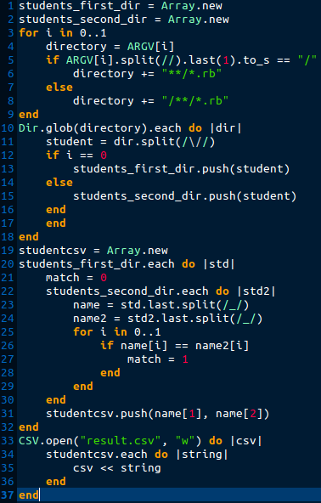

Errors:

* In line 31:in `block in <main>': undefined local variable or method `name' for main:Object (NameError)
* Check for files format is missing
* “require "csv"” is missing

New code:

